Name: _______________________________________ Date: ________________________________
Triangle Sum, Base Angles, & Exterior Angles

Triangle Sum Theorem
The sum of the ______________ ______________ in a triangle is ___________.
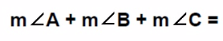
Example one:
Find x and all angle measures for the following:
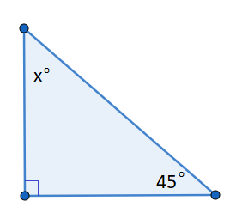
Example two:
Find x and all angle measures for the following:
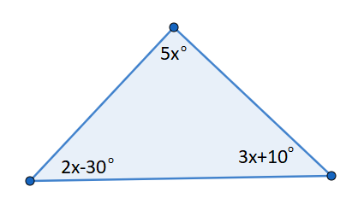
Example three:
Find x and all angle measures for the following:
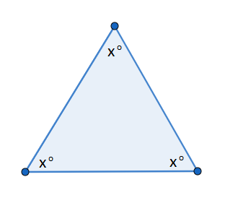
Example four:
Find x and all angle measures for the following:
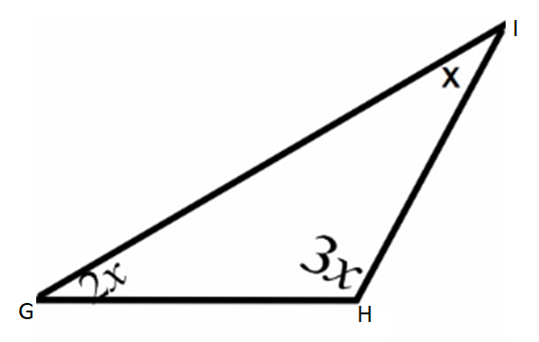

Exterior Angle Theorem
The measure of an ______________ ______________ of a triangle is equal to the _________ of the measures of its _______________ _____________ angles.
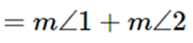
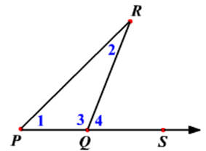
Example one:
Find x and y.
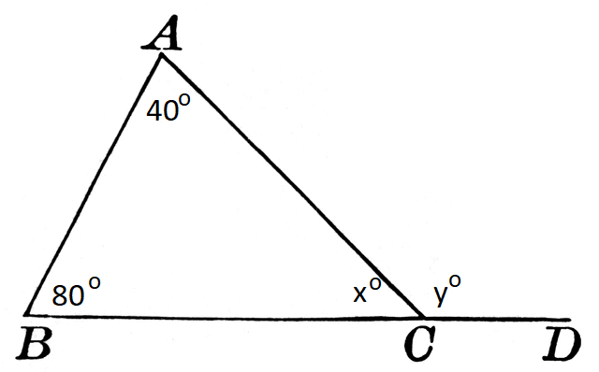
Example two:
Find x and y.
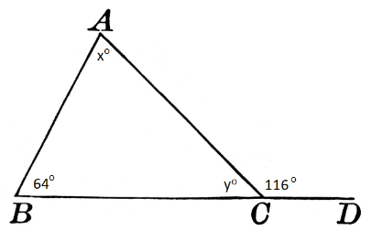
Example three:
Find x and all missing angle measures for the following:
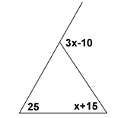
Example four:
Find x and all angle measures for the following:
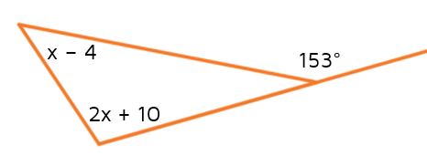

Base Angles of a Triangle
Base Angle Theorem: If 2 ______________ in a triangle are congruent, then the ________________ opposite them are congruent.
Base Angle Theorem Converse: If 2 ______________ in a triangle are congruent, then the ________________ opposite them are congruent.

Equilateral Triangle Corollaries
Corollary 1: If a triangle is ____________________, it is ______________________.
Corollary 2: If a triangle is ____________________, it is ______________________.

Example one:
Solve for x.
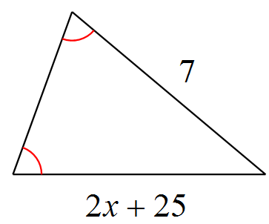
12
Example two:
Find x, y, and all missing angle measures
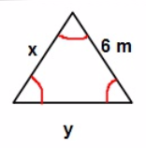
Example three:
Find x, y, and all the measure of all angles in the triangle.
