Name: _______________________________________ Date: ________________________________
How to Prove Triangle CongruenceNot-so-obvious congruence you can use:
If some angles or sides are unmarked, you can use these to mark them as congruent.

- __________________________________________ EX:

- __________________________________________ EX:
(only with parallel lines)

- __________________________________________ EX:
(shared side)

Triangle Congruence Postulates

- Side-Side-Side (SSS)
If 3 ___________ of a triangle are ____________________ to 3 ____________ of another triangle, then the two triangles are ____________________.
Draw me:

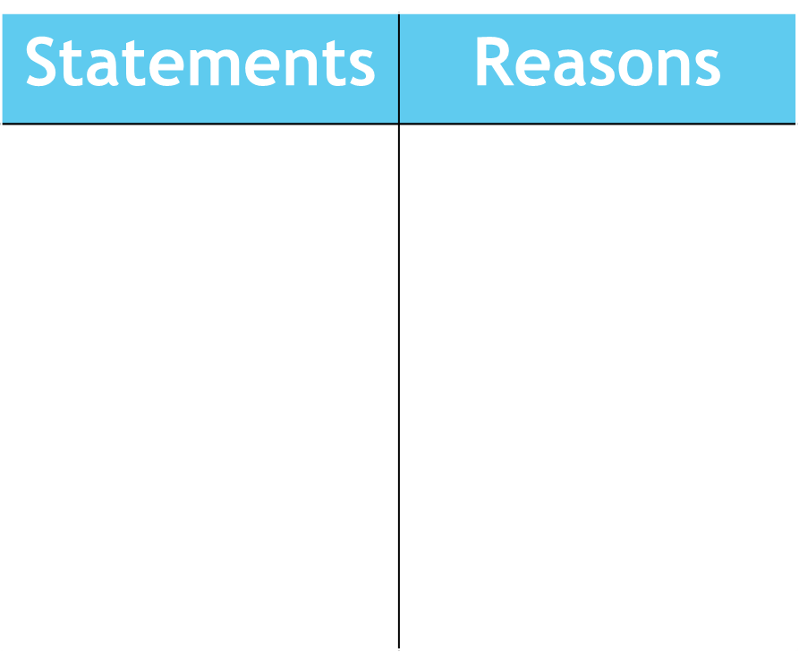
Example:
Prove ∆DEF ≅ ∆GHI

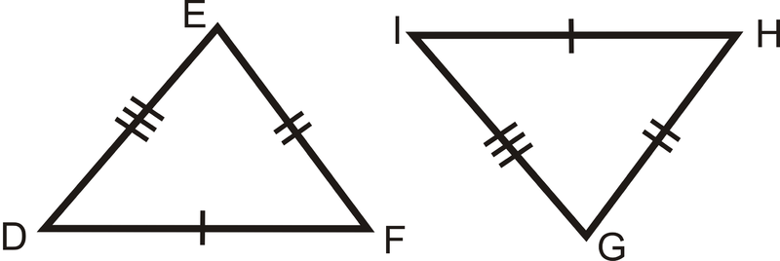

- Side-Angle-Side (SAS)
If 2 _______________ and the __________________________ of a triangle are _______________________ to 2 ________________ and the __________________________ of another triangle, then the two triangles are _______________________.
Draw me:

Example:
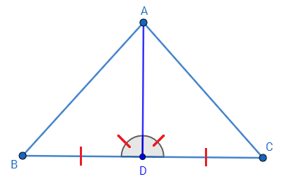
Prove ∆ABD ≅ ∆ADC

- Angle-Side-Angle (ASA)
If 2 _______________ and the __________________________ of a triangle are _______________________ to 2 ________________ and the __________________________ of another triangle, then the two triangles are _______________________.
Draw me:

Example:
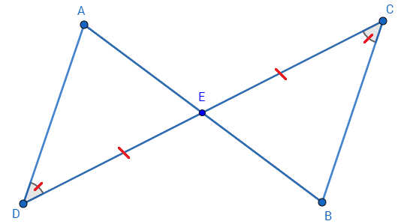
Prove ∆ADE ≅ ∆CBE

- Angle-Angle-Side (AAS)
If 2 _______________ and the ________-___________________________ of a triangle are _______________________ to 2 ________________ and the ________-___________________________ of another triangle, then the two triangles are _______________________.
Draw me:

Example:
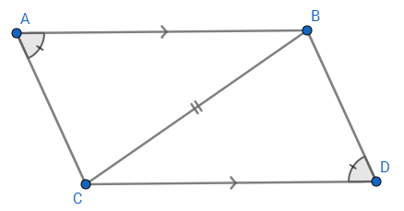
Prove ∆ABC ≅ ∆BCD

- Hypotenuse-Leg:
Two ________________________ are congruent if they each have a congruent ___________________ and a congruent __________.
Draw me:

- Angle-Side-Side:
Don’t be one! This is NOT a method of proving triangle congruence!

Example:

