**I. Write the congruence statement for each pair of triangles.**

1. 2. 

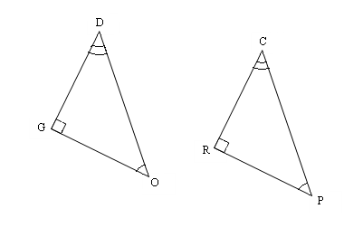

**C**

**O**

**G**

**R**

**A**

**E**

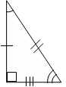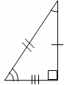3.  4. 

A

I

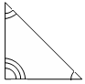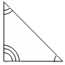

B

O

X

F

O

X

E

L

R

N

**II. Name the congruent triangle and the congruent parts.**

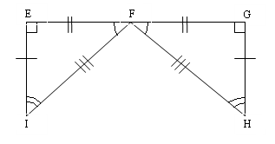7. 

 

 

 

Use the congruency statement to fill in the corresponding congruent parts.

8.    

  

**III. Knowing the following triangles are congruent, find the missing variable.**

9. . Find x. 10.  Find y.

R

Q

N

M

P

x°

A

B

C

D

(3y)°

21°

35o

11. . Find x. 12. . Find a.

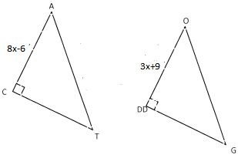 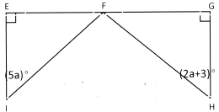

13. . Find JK

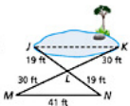

**IV. For which value(s) of *x* are the triangles congruent?**

14. *x* = _______________ 15. *x* = _______________

A

D

1

m ∠3 = *x*2

m ∠4 = 7*x* - 10

B

E

C

2

3

4

4*x* + 8

7*x* - 4

A

B

R

C