Quadrilaterals – Parallelograms
The prefix QUAD- means ___________________.
A quadrilateral is a ________________-_______________________ polygon.
Naming a quadrilateral: Pick ___________ __________________, then name them off in ______________________ order.
Ex:
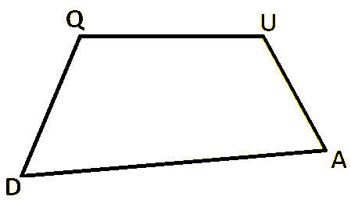
Consecutive: one ___________________ the other.
Diagonals

Consecutive sides:
Consecutive vertices:
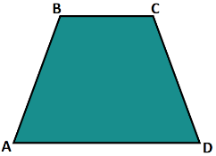
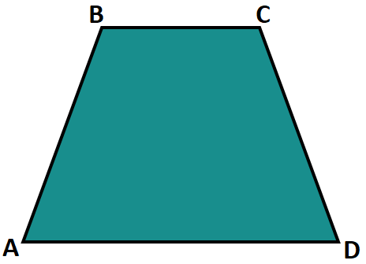

Interior Angles
The angles in a quadrilateral add up to ________________________.

Ex: Find x.
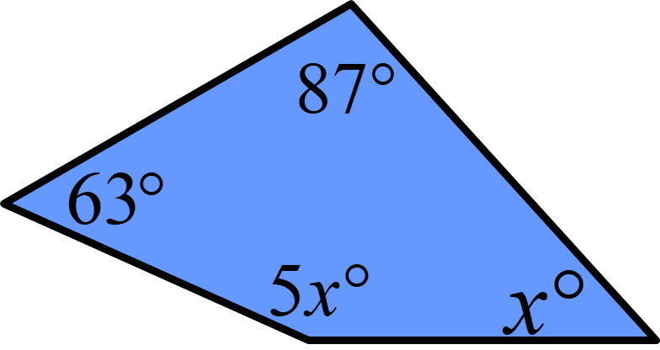
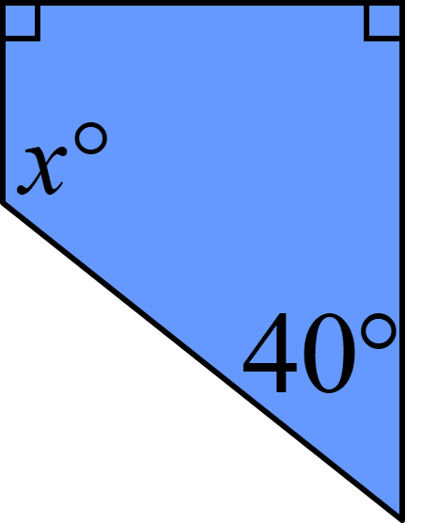

Organizer Review:
 | Parallelogram | Rectangle | Square | Rhombus
Opposite Sides //
Opposite Sides $≅$
All Sides$≅$
All Angles$≅$
Opposite Angles$≅$
Consecutive Angles Supplementary
Diagonals Bisect Each Other
Diagonal are$≅$
Diagonals are Angle Bisectors
Diagonals are Perpendicular

Properties of Parallelograms
Ex2: List the quadrilaterals for which the statements are true.
a) The diagonals are congruent b) The diagonals bisect the angles c) The diagonals are perpendicular

Ex2 List the quadrilaterals for which the statements are true:
a) Both pairs of opposite sides are parallel. b) Both pairs of opposite sides are congruent.

c) All angles are congruent. d) All sides are congruent.

Solving Opposite Sides and Angles in a Parallelogram: SIDES AND ANGLES
EX1: Ex2:
105º
2x – 5 º
x + 20
70

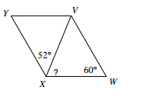
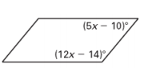
Ex 3: Ex4:

Solving Opposite Sides and Angles in a Parallelogram: DIAGONALS
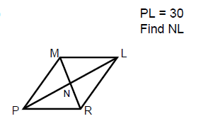
Ex5: Ex6:
