Name ___________________________________________ Date_______ Period_________ Seat_______________

Answer each question completely, showing your work.
1. The vertices of a triangle are P(3, 8), Q(–9, 5), and R(3,3). Name the vertices of the image reflected Over the x-axis. ___________________________

Over the y – axis: ________________________
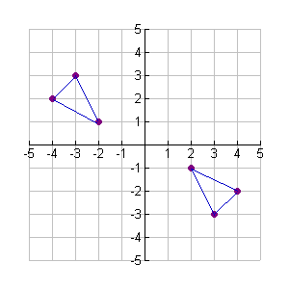
- Which of the following transformations is illustrated by the graph at the right?

- The image of (-2, 6) after a dilation with respect to the origin is (-6, 18). What is the scale factor of the dilation?

- Given the point (-4, 3), where will its image be after the translation (x, y) -> (x – 2, y + 4)?

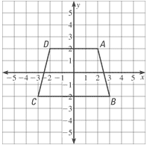
- Describe the following transformation from ABCD to A’B’C’D’ if D’(2,2) A’(2,-2), B’ (-2, -3) and C’ (-2,3)

- Define bisect.

- Define perpendicular lines.

- Define regular polygon.

- If the following transformations takes place on a polygon, describe the results: A. (x , y) -> (x, 4y)
B. (x, y) -> (5x, y)

- Describe the steps in constructing the perpendicular bisector of a segment. (You may use your text or an online resource)

- If the center of a circle is at (-3, -5). After the transformation (2x+ 5, 2y – 7), where will the center be?________________________

- What is the center of the above dilation? 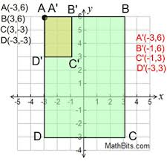

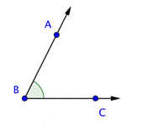
- Name the angle above in all possible ways. Can we name the angle <BAC? Why or why not?

- Complete the steps to inscribe a square in a circle.

- Draw a _____________________.
- Draw a ______________________.
- Find the _____________________ _________________ of the diameter.
- Connect the __________________ on the circle.

- Suppose ABCD is transformed so that image of D is (-4, -1). Write a general rule that describes the transformation.

- Describe the transformation that has taken place below:
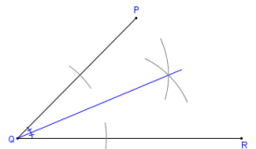
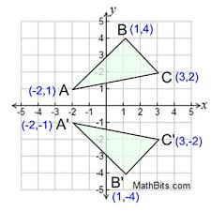
- What construction has taken place?

- What is the center of dilation for the Transformation below?

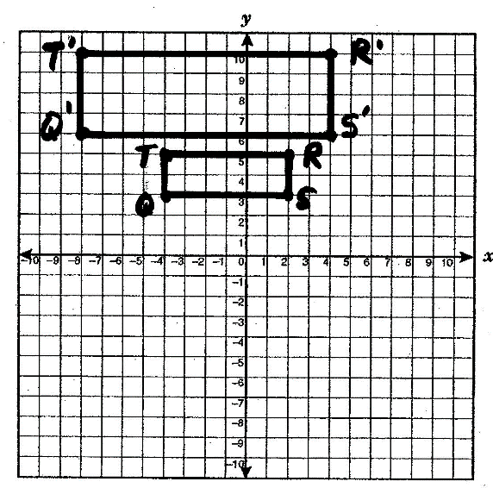

- For A – D, name each construction:

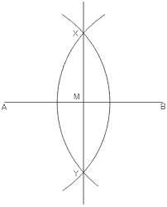
A.________________________

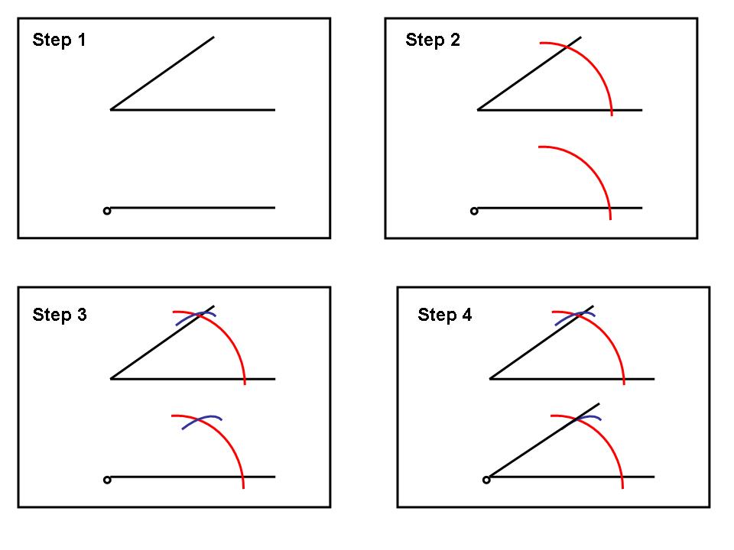
B.________________________

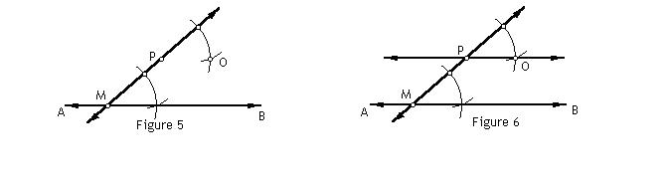
C.__________________

D._________________ The construction that proceeds as follows:
- A diameter of the circle is drawn.
- A perpendicular bisector of the diameter is drawn using the method described in Perpendicular bisector of a segment. This is also a diameter of the circle.
- The resulting four points on the circle are the vertices of the inscribed square.

- Define a polygon inscribe in a circle.

- Using the drawing below, if m<HGI = 64º and ray GM bisects <HGI, what is m<HGM?

