The heights of very tall structures can be measured indirectly using similar figures and proportions. This method is called indirect measurement.
https://www.youtube.com/watch?v=QWcq4wToTlA

Your assignment is to find the height of a tree, a light pole, or a building on campus. You will calculate the height using the shadow method!
Shadow Method Shadow Reckoning: Go to your tree and measure the shadow cast by the tree. Then measure the length of the shadow of a student from your group, who stands by the tree (but not in it's shadow). Measure the student's height. Then draw a sketch of the tree and the student, label the sketch with the measurements, and calculate the height of the assigned object.
\
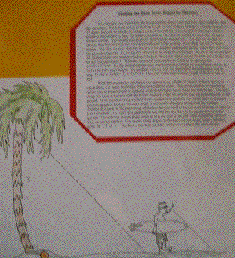

Summary:
1. Fill out your group duty chart.
Outside: Calculate the height of the tree shadow, your teammate’s shadow, and your teammate’s height
2. Inside: Draw the tree/pole/building, the student, and both shadows on your paper.
2. Explain every step of your work; Set up proportions and label (MUST SHOW ALL WORK)
3. Write these explanations clearly and completely, including all of equations and any theorems that you use. This explanation will be part of your "picture".
4. Answer the questions #1-3

1. Explain why the triangles are similar, in each case.

2. How might these methods be useful in other situations?

3. Do you think this might be how people in earlier times might have measured objects too tall to measure directly?

 | Group Names | Materials Collector | Recorder | Measurement Specialist | Artist (Draw Diagram) | Labeling/Accuracy Manager
1
2
3
4

EVERYONE MUST TURN IN WORK!!!
Picture:

