PRACTICE

You can take the practice Quizizz as many times as needed

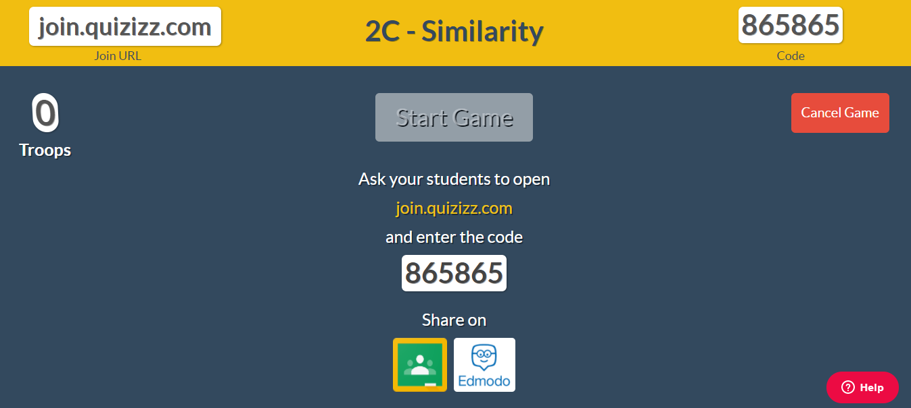

2C Similarity QUIZ CODE/ Scratch Paper

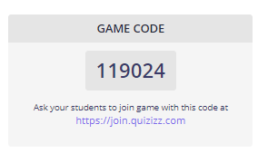

MUST TURN IN FOR QUIZ TO BE GRADED

