2C Similarity CDA Review
- In the diagram of $∆ABE$ and $∆DBC$, $\overline{AD}$ and $\overline{CE}$ intersect at B and $∠EAB≅∠CDB$.
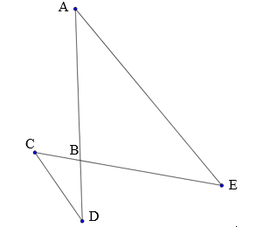
What statements prove these two triangles are similar by AA?

- Given $∆ABC\sim ∆DEF$ such that $\frac{AC}{DF}=\frac{2}{3}$. What are all of the other ratios and congruent angles?

- If $∆ABC \sim ∆JKL$, $m∠A=59°, and m∠B=63°$, what is $m∠L$?

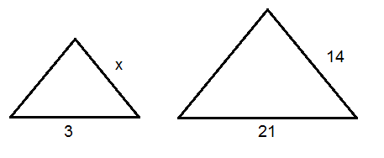
- Solve for x.

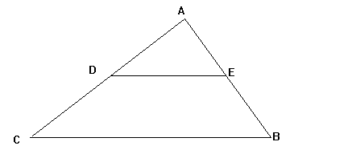
- Given that $∠ABC≅∠AED$, determine how these two triangles are similar.

- Two ladders are leaned up against a wall such that they make the same angle with the ground. The 12’ ladder reaches 9’ up the wall. How much further up the wall does the 21’ ladder reach?
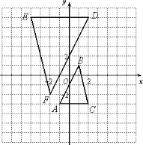
- Determine the scale factor and whether it is an enlargement or reduction.

- Are these two triangles similar, and if so how?
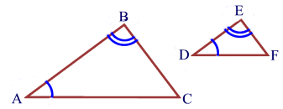
- Are these two triangles similar, and if so how?
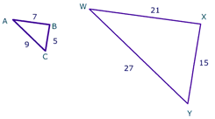
- Solve for x, y, and z.
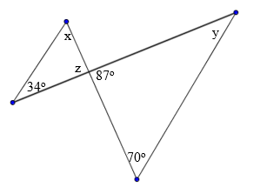

- Solve for the missing side. The triangles are similar.
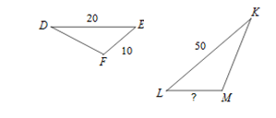
- The side lengths of $∆ABC$ are 2, 5, and 8 and the sides of $∆RST$ are 4, 10, and 18 respectively. Are the two triangles similar and if so, which postulate or theorem can be used to prove the triangles similar?

- Find the value of x if the two triangles are similar.

- Solve for x. Assume the two triangles are similar.

- The following two triangles are similar. Solve for x.
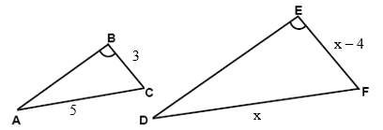

- Similar triangles are triangles that are the same shape, but not the same size. What ways can triangles be proven similar?

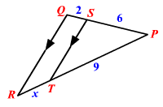
- A line parallel to a triangle’s side splits one side into lengths of 6 and 2. The other side is split into lengths of 9 and x. What is the value of x that would prove the parallel line divides the sides proportionally?

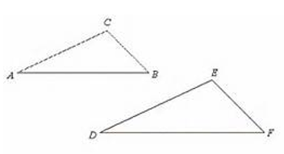
- The triangles below are similar. Write the similarity statement and determine the value of x..
m$∠$A = 35º
m$∠$C = m$∠$E = 102º
m$∠$B = 43º
CB = x + 2, AC = 5, DE = 10, EF = 6

- Determine if the triangles shown in the figure are similar. If so, state the reason.

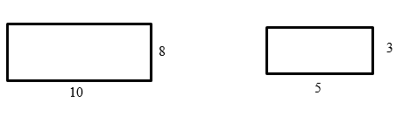
- Are the following polygons similar?

a.
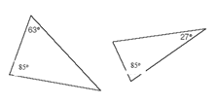
b.

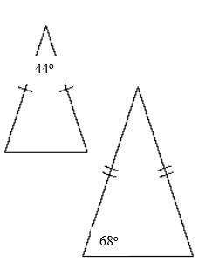
c.

- Solve for x.
