SOH CAH TOA is a way of remembering the 3 primary right triangle trigonometric functions: sine, cosine and tangent. Recall that:
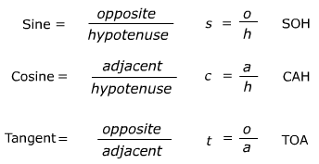
There are several good mnemonic devices for learning the ratios. Here are some examples below:
- Some Old Horse Caught Another Horse Taking Oats Away

- Silly Old Henry Caught Albert Hugging Two Old Aunts

- She Offered Her Cat A Heaping Teaspoon Of Acorns

- Some Old Hag Cracked All Her Teeth On Apples

- Some Old Hags Cackle And Howl Till Old Age

TASK: Use the back of this page to create your own mnemonic for remembering SOHCAHTOA!
Guidelines
- Practice on a separate sheet of paper, final copy should be on the back of this paper
- Final copy must make sense (no random words)

- Draw an illustration of your mnemonic

- Final copy must be colored

S
O
H
C
A
H
T
O
A

