Name: ________________________________________ Date: ______________________________
Trigonometry Ratios

Greek letter θ is pronounced “______________” and represents an __________________ ___________________.

SINE | COSINE | TANGENT
Pronounced: | Pronounced: | Pronounced:
Sinθ = | Cosθ = | Tanθ =

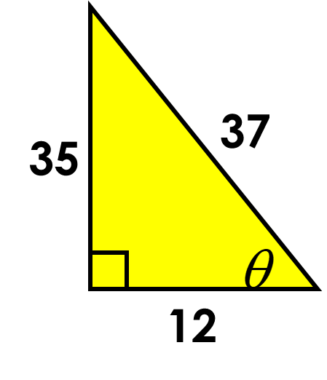
Example one: Find the sine, the cosine, and the tangent of theta. Give a fraction.
Sinθ =
Cosθ =
Tanθ =
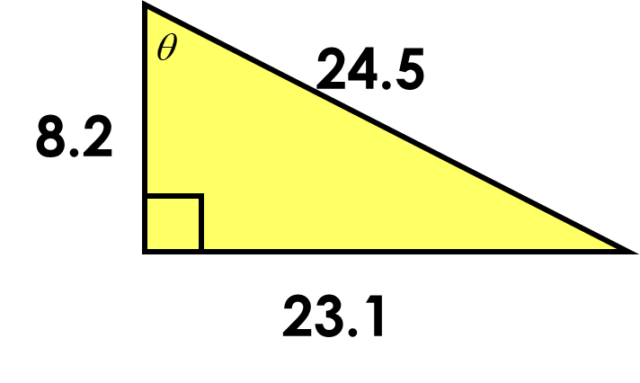
Example two: Find the sine, the cosine, and the tangent of theta.
Sinθ =
Cosθ =
Tanθ =
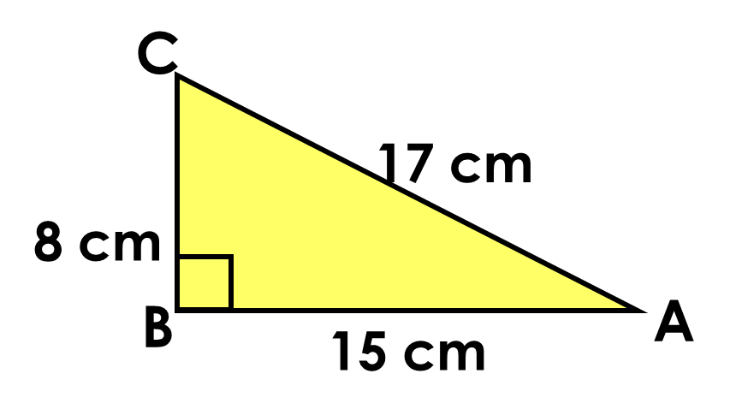
Example three: Find the sine, the cosine, and the tangent of angle A.
SinA =
CosA =
TanA =

Example four: Find the sine, the cosine, and the tangent of angle C.
SinC =
CosC =
TanC =
Example five: $Draw ∆ABC where$
Example six: $Draw ∆ABC where<ABC={90}^{o},$
$$AB=12, AC=13, BC=5$$

- What is Cos A?
- What is Sin A?
- What is Sin B?

$$<ABC= {90}^{o}, AB=12,$$
$$BC=9 and AC=15.$$

- What is tan C?
- What is Sin A?

Example eight: $Draw ∆HAT where<HAT= {90}^{o},$
$$HA=16, HT=20$$
- What is the length of AT?
- What is Cos T?
- What is Tan H?

Example seven: $Draw ∆CAT where$
$$<ATC= {90}^{o},$$
$$CT=14, TA=48$$
- What is the length of AC?
- What is Cos A?
- What is Tan C?

Example ten: $Which trig ratio is represented?$
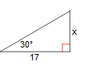

- Sin
- Cos
- Tan
Example nine: $Draw ∆BAT where$
$$<BTA= {90}^{o}, BT=12, BA=15$$
- What is the length of TA?
- What is Sin B?
- What is Sin A?

