Name: ________________________________________________________ Date: _______________________
Ratios in Similar Polygons
Fill in the blanks to complete each definition.
- A similarity ratio is the ratio of the lengths of the ____________________ sides of two similar polygons.
- Two polygons are similar if and only if they meet the following criteria:
- Corresponding angles are ____________________.
- Corresponding sides are ____________________________.
ΔABC ΔDEF
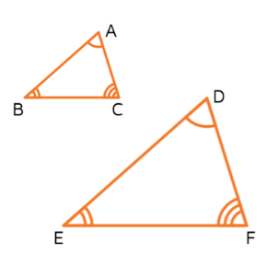
- Similar polygons have the same shape but not necessarily the same
____________________.

- Similarity statement:
Use the figure for Exercises 1 and 2. ∆ABC ~ ∆FED
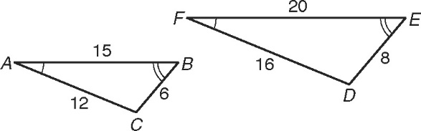
1. Name the pairs of congruent angles.
∠A ≅
∠B ≅
∠C ≅
2. Write the corresponding side lengths in the proportion. $\frac{ }{ AB }=\frac{ DE }{ }=\frac{ }{ FD }$
Use the figure to the right for Exercises 3 and 4. The triangles are similar.
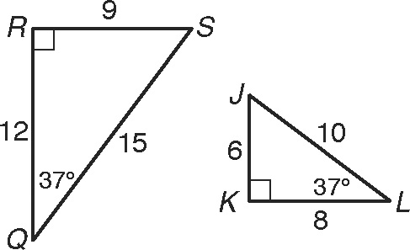
3. Circle the correct similarity statement.
ΔQRS ~ ΔKJL ΔRSQ ~ ΔKJL ΔQSR ~ ΔLKJ
4. Write the corresponding side lengths in the proportion.
$\frac{ }{ RS }=\frac{ KL }{ }=\frac{ }{ }$

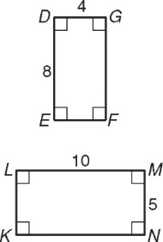
Use the figure to the right for Exercise 5.
5. Substitute numbers for the side lengths and reduce each ratio to simplest form.
$\frac{MN}{DG}$ = _______ $\frac{ML}{DE}$ = _______ = _______

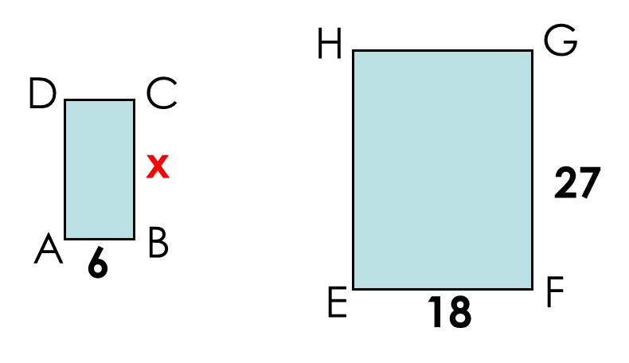
Use the figure to the right for Exercise 6.
6. ABCD ~ EFGH. Solve for x.

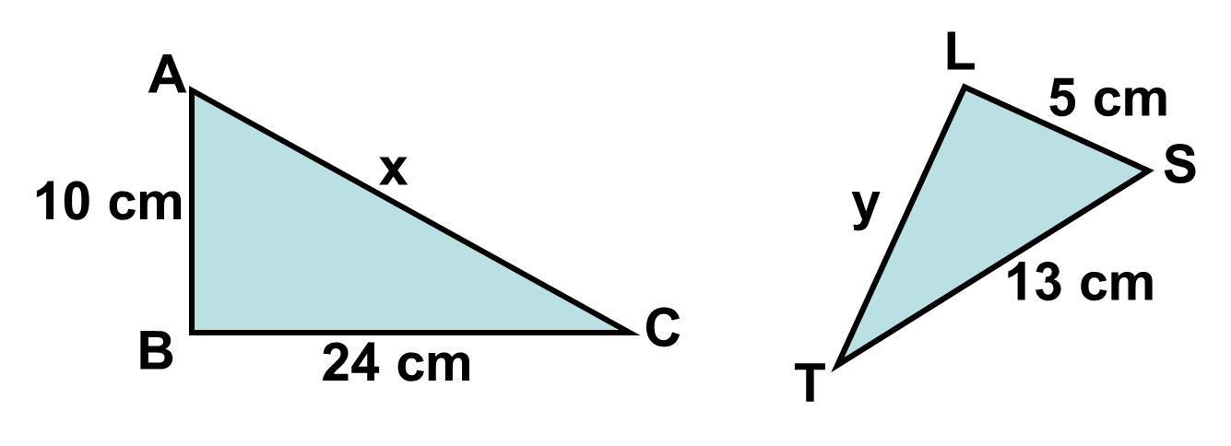
Use the figure to the right for Exercise 7.
7. Solve for x and y.

Word Problem: A tree cast a shadow 18 feet long. At the same time a person who is 6 feet tall cast a shadow 4 feet long. How tall is the tree?
$$\frac{ }{ }=\frac{ }{ }$$

Ratios of similar polygons — Corresponding side: Corresponding side
OR
Perimeter: Perimeter Area: Area Volume: Volume
_________:_________ _________:_________ _________:_________
Example: Find the perimeter of the smaller triangle.
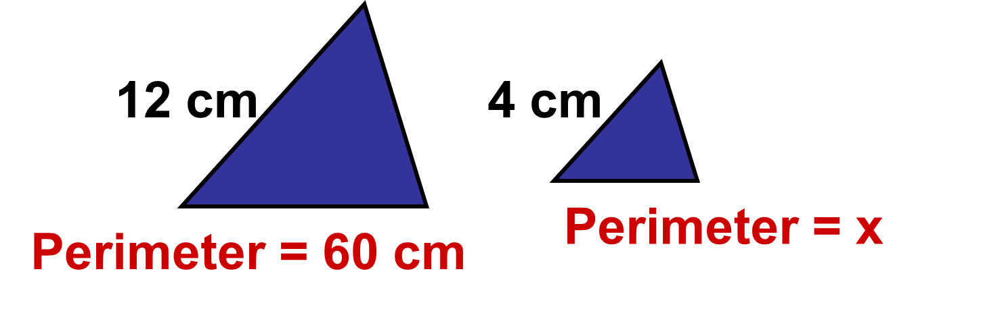
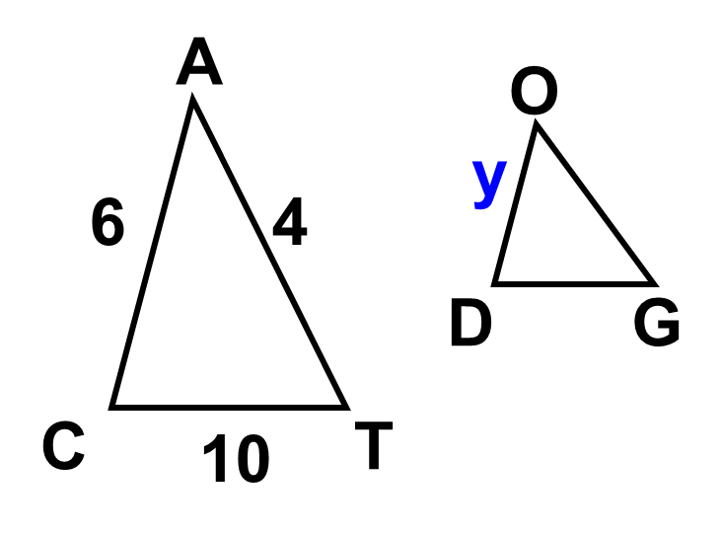
Example: The ratio of the perimeters of two similar polygons equals the ratio of any pair of corresponding sides.
The ratio of the perimeters of CAT to DOG is 3:2. Find the value of y.

Scale Factor

Scale Factor – the ratio of corresponding sides

- When scale factor is greater than 1, the shape gets bigger and this is called an ___________________________.
- When scale factor is less than 1, but greater than 0, the shape gets smaller and this is called a _______________________.
- Formula: __________

Dilations

Apply the dilation D to the polygon with the given vertices. Name the coordinates of the image points. Identify and describe the transformation as an enlargement or reduction.

8. D (x, y) →
A(4, 10), B(–6, 4), and C(4, –4)
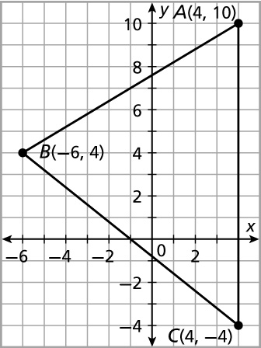

A’ _________, B’ _________, and C’ _________

This shape is a/n __________________________.

The scale factor is _________.

9. D (x, y) → (3x, 3y)
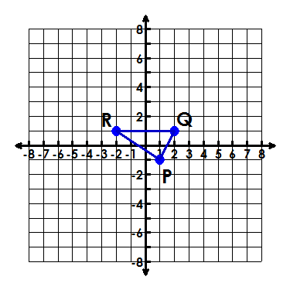
P(1, –1), Q(2, 1), R(–2, 1)

P’ _________, Q’ _________, and R’_________

This shape is a/n __________________________.

The scale factor is _________.

