Find the given trigonometric ratio.
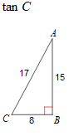
1. 2.
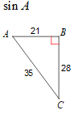

3. 4.
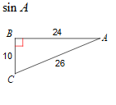
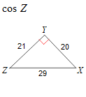

5. 6.
Draw ΔHAT where ∠H = 90° and Tan A = $\frac{9}{40}$
  - What is the length of AT?
  - What is sin A?
  - What is cos T?

Draw ΔCAT where ∠ATC = 90°, CA = 15, and CT = 9.
- What is the length of AT?
- What is sin C?
- What is tan A?

7. 8.
Sin A = .843 then cos B = ______

Sin 38º = cos ______º

9. 10.
Solve for x if Sin (3x + 5)º = cos(x + 9)º

Draw ΔABC where ∠ACB = 90°, AC = 9, and CB = 12.
- What is the length of AB?
- What is cos A?
- What is tan B?

