Name: ________________________________________ Date: ______________________________
Finding Missing Sides in Right Triangles

When we are trying to find a side we use _____________, _____________, and ________________.
Remember:
$$\sin{θ= \frac{ }{ } \cos{θ}=\frac{ }{ } \tan{θ}=\frac{ }{ }}$$
Trig buttons:
- Appear as “___________”, “___________”, and “___________” on your calculator.
- ALWAYS: Check that your calculator is in ____________________ MODE!!!
- Sin 20 ≈ _________
- Tan 30 ≈ _________
- Cos 5 ≈ _________
- Sin 85 ≈ _________
- Tan 69 ≈ _________

Step 1
Step 2
Step 3

Ex. 6 Figure out which ratio to use, then find x. Round to the nearest tenth.  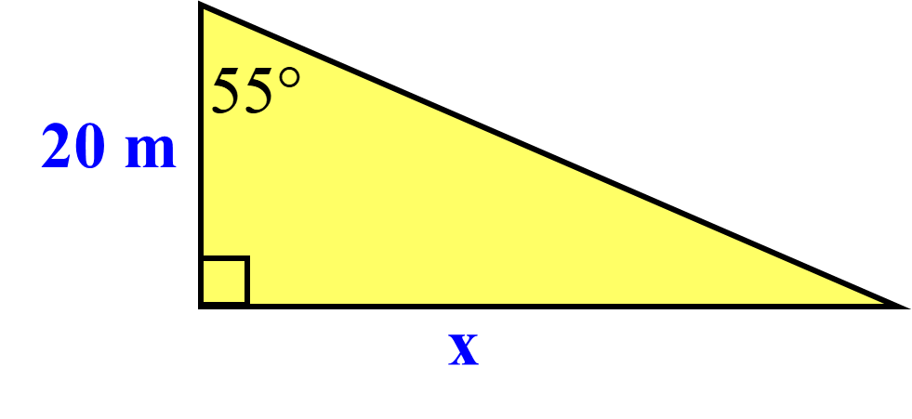 | Ex. 7 Find the missing side. Round to the nearest tenth.  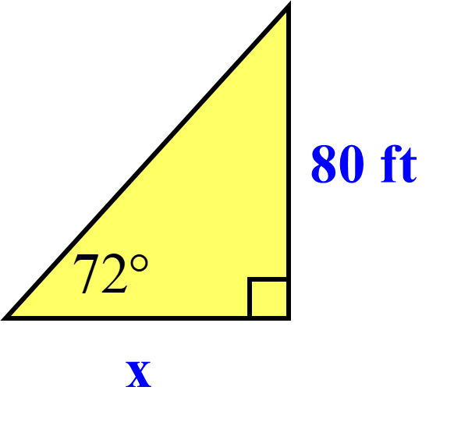
Ex. 8 Find the missing side. Round to the nearest tenth.  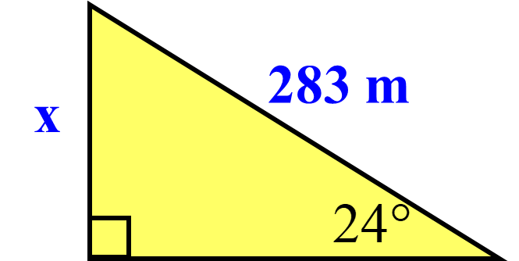 | Ex. 9 Find θ. Round to the nearest degree.  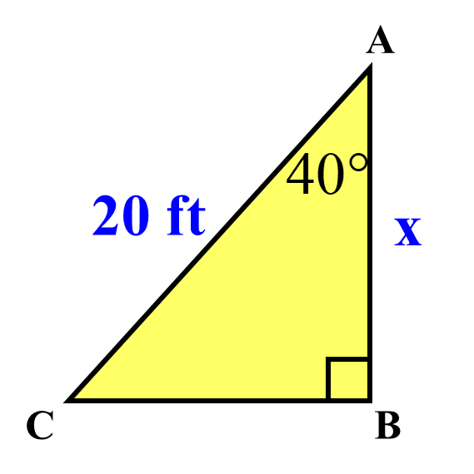
Depression and Elevation

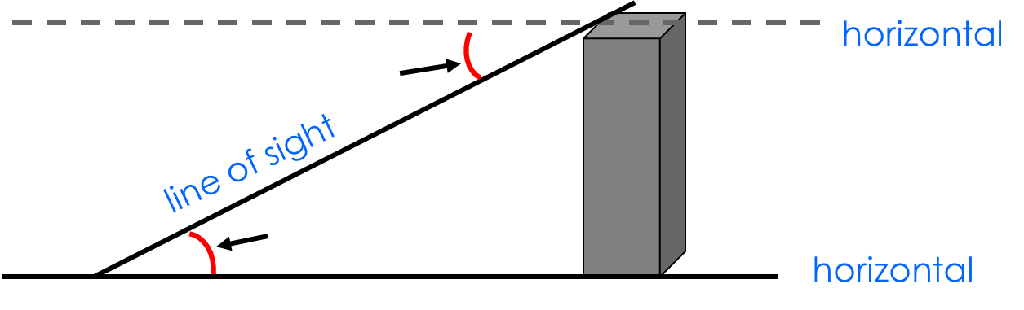
Practice: Classify each of the numbered angles as angle of depression or angle of elevation

Ex 5. A construction worker leans his ladder against a building making a 60º angle with the ground. If his ladder is 20 feet long, how far away is the base of the ladder from the building?

Ex 6. The angle of depression from the top of a tower to a boulder on the ground is 38º. If the tower is 25m high, how far from the base of the tower is the boulder? Round to the nearest whole number.

Ex 7. The outline of a teepee is shaped like an equilateral triangle. If the sticks on the side are 12 feet long how tall is the teepee?

