Putting General Form in “Order”
EX1: 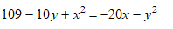

Ex2: 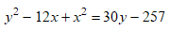

Ex3: 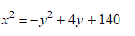

_________________________________________________
STEPS
- Write the equation in order
- Divide the x coefficient by 2
- Square that number & add to the end
- Divide the y coefficient by 2
- Square that number & add to the end
- Take the square root of that sum as the radius
- Take the opp. of step 2 and step 4 as the center (h, k)
Identify the center and the radius
EX1:

EX2:

EX3: 