Unit 6 Review

- On this coordinate grid, Target is located at point A, the movie theatre is located at point B, and the school is located at point C. Each grid line represents 1 mile. How much farther to the nearest tenth of a mile, is the Target from the school versus Target from the movie theatre?

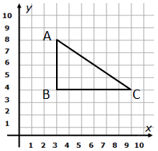

- In the diagram below, if a line segment was drawn between points A and B on the graph, the midpoint of the segment would be__________________.
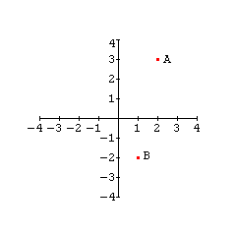

- Parallelogram EFGH has the following coordinates: point E (1,0), point F (3,2),
point G (5,0). Find the coordinates of point H.
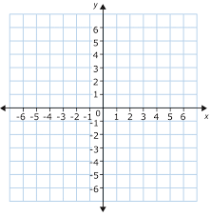

- Find the equation of a line parallel to the line $y=\frac{1}{3}x+2$ that passes through the
point (-3, 3).

- Find the equation of a line that passes through the point (-1, 6) and is perpendicular to the line $y=\frac{1}{2}x-4$.

- Using the graph below, write the equation of a line that is parallel to the line shown and passes through the point (-3, 5).

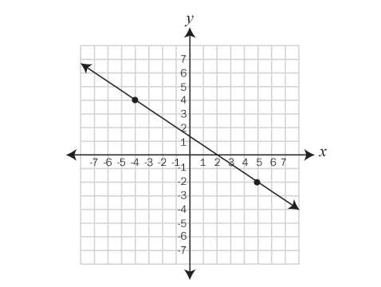

- Using the graph below, find the equation of a line that is perpendicular to the line shown and passes through the point (2, -3)

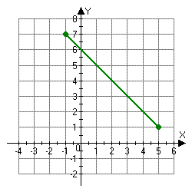

- Determine the area of the given triangle on the coordinate plane.

- A segment has an endpoint at (4, -1) and a midpoint at (-2, 5). Determine the coordinates of the other endpoint.

- Which of the following is the most specific classification of quadrilateral QRST with vertices Q(-4, -2), R(-2, -2), S(-1, -4), and T(-4, -4)?

- Which geometric shapes are in the image?

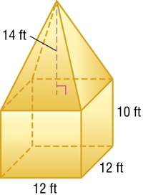

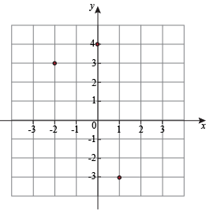
- In the diagram below, given that the points (-2, 3) and (1, -3) are vertices of a rectangle, what are the other two sets of coordinates that could form the other vertices?

- Mike is building a garden and needs to fence it in to keep the deer out. He has identified where the corners of the garden will be and mapped them on a coordinate plane. Four posts will be placed in the corners and the labeled them as Q(-2, 1), R(3, 1), S(3, 4), T(-2, 4). How many square feet will the garden be?

- In the diagram below, what is the perimeter of the triangle? Round your answer to the nearest hundredth.
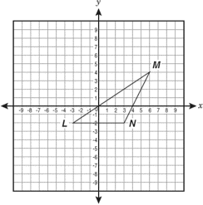

- Convert the equation below to standard form. x² + y² – 8x + 10y = -21

- Write the equation of the circle graphed below.
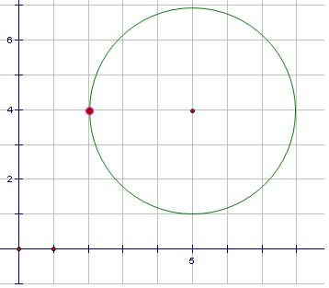

- Consider the equation of a circle, (x + 3)² + y² = 49. The center is ___ and the radius is __.

- A cone made of steel has radius 14 cm and height 25 cm. If the density of steel is 8.05 g/cm³. What will the cone weigh in grams? Round to the nearest whole number.

- Graph (x + 3)² + (y – 1)² = 4
- A square pyramid is packaged inside a box. The space inside the box around the pyramid is then filled with protective foam. About how many cubic inches of foam is needed to fill the space around the pyramid?
4 cm
4 cm
4 cm

