DISTANCE FORMULA D =

EX1: (-7, -6), (1, 3) EX2:
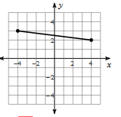

MIDPPOINT FORMULA (x, y) = _____________ , ___________

EX1: (-2, 10), (7, 9) EX2: (-6, 10), (10, 2)

BACKWARDS Given the midpoint and one endpoint o a lien segment, find the other endpoint.
EX3: Endpoint: (-8, -9), midpoint: (-5, 0) EX4: Endpoint: (-3, -6), midpoint (-2, 7)

SLOPE FORMULA: M = ____________
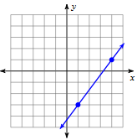
EX1: (-1, 7), (14, 17) EX2:

